GPS+Camera Projects: Parallel Curricula and a Common Website

GPS+Camera EFS Projects
3/26/2012
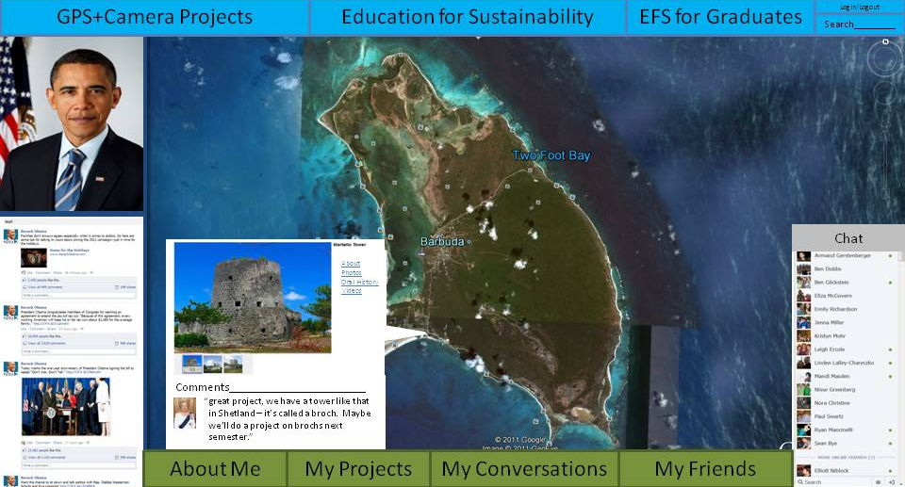
The Challenge of the 21st Century
In the 21st century, environmental sustainability will be one of humanity's greatest challenges. Across the globe we have created patterns of population growth, production, consumption and settlement that erode the very bedrock they are built upon. Island nations, like Antigua and Barbuda, are particularly vulnerable to climate change and environmental degradation. From rising sea levels, to more powerful storms, to the sustainable management of renewable marine resources, island nations face unique environmental challenges. Education will play a vital role in overcoming these challenges.

New Skills for New Problems
Addressing complex environmental issues will require a new kind of citizen and a new set of skills. Over the past several decades, a new pedagogical perspective, Education for Sustainability, has arisen that seeks to develop students able to meet the environmental challenges of this century. Education for Sustainability (EFS) aims to produce students who are:
- Sustainability-literate
- Critical Thinkers
- Systems Thinkers
- Futures Thinkers
- Empowered to Enact Change
- Global Citizens
EFS is not simply the introduction of environmental science classes into formal education curricula but rather the mainstreaming of environmental consciousness across educational disciplines. It encourages an environmental history perspective in social studies, encourages the selection of readings that promote environmental awareness in literature classes and promotes the use of environmental data as the 'hidden curriculum' in mathematics classes.
But what does EFS actually look like in the classroom? Pedagogical fads come and go and often leave overburdened teachers with more work or an idealistic mandate with no practical means of implementation. How can we create an Education for Sustainability program that will connect sustainability with place, empower students to be agents of change in their own communities, and build opportunities for regular sustainability dialogue without radically changing the year-round curriculum or giving teachers even more work?

GPS+Camera Projects
In a GPS+Camera Project, a high school teacher is given a camera and a GPS. Teachers use a preexisting curriculum to implement sustainability field projects adapted for local conditions and the teacher's subject. The camera is used to record video and take pictures of the projects. The GPS is used to spatially locate where different aspects of the program take place. The projects are brief, only 4-6 classes long, with one project per subject per school year. The GPS+Camera Projects in Barbuda will start with biology, geography, social studies, mathematics, history, home economics, agriculture science and could be expanded in the future. The projects are staggered throughout the year so if high school students take six subjects, then three projects would be done in the fall semester and three projects would be done in the spring. This avoids overburdening any one teacher while giving students year-long interdisciplinary engagement with sustainability.

Social Networking Website for International EFS Youth Dialogue
The GPS+Camera Projects help students learn about sustainability, about place and about how issues of sustainability impact their communities (and vice versa). But environmental sustainability is a task no one community can achieve by itself. How do we create systematic opportunities for students to engage in sustainability dialogue with other communities?
The GPS+Camera Website aims to answer that question. The video, photos and student reflection papers created in the GPS+Camera Projects will be uploaded onto a website and spatially referenced using the GPS. The result will be an interactive satellite map, much like GoogleEarth, where users can zoom in and out and click on nodes on the map. The nodes will represent spatially referenced student EFS projects with photos, videos and student reflection papers.
The website will also include a social networking component like a limited version of Facebook. Students will create a profile and be able to upload content. In the same way that a Facebook user can leave comments on a photo, our students will be able to leave comments on other schools' projects. The website will allow students to publish their own research, explore research on similar topics in other countries and engage in conversations about sustainability with youth researchers internationally. The website will also feature a forum (called "My Conversations" in Figure 1) where students could discuss off-topic subjects from sports, to food to their favorite music.
Figure 1: The GPS+Camera Website combines features of GoogleEarth with social networking platforms like Facebook
Students would be doing real sustainability research in their own communities, publishing that research and engaging in sustainability dialogue. After the pilot year in Barbuda, the GPS+Camera Projects could be expanded to collaborating schools in New York City, Scotland, Iceland and elsewhere, bringing students from many countries into sustainability dialogue.

A Pilot Project
Codrington has had a long and rich history that has produced numerous historic sites and buildings around town. A short GPS+Camera Project designed to emphasize place-based learning, community dialogue and preservation of local heritage could be an effective means of pilot testing the GPS+Camera program in the Barbudan school system. A short one to two week-long project with a limited number of select students could be undertaken. Students could learn about oral histories, primary sources, interview techniques and the proper use of GPSs and cameras. Students could then research local historic sites including writing, conducting and videotaping interviews with community members and local experts. The student's work would result in 1) public information posters that could be posted by local historic sites, 2) videotaped interviews, photos of historical sites and student written work about the historic sites that could be uploaded to the GPS+Camera website with links to Barbudan tourism and government webpages and 3) a presentation of our findings designed for the community.

Parallel Curriculum, Adapted for Local Circumstances
GPS+Camera Projects currently exist in multiple countries but still require an official curriculum. By creating parallel curriculum with similar projects adapted to local circumstances, students will be more easily drawn into dialogue. Similar projects will allow in Scotland, Iceland, the United States, and Antigua and Barbuda to discuss successes and challenges as they engage in experiential learning.
Sustainability will be one of the greatest challenges of our students' lifetimes. Students will need to be sustainability-literate, spatially-literate, empowered to take action in their own communities and connected with other young people around the world. GPS+Camera Projects create a low cost, easy to implement means of integrating an interdisciplinary sustainability perspective to preexisting high school curricula. The GPS+Camera Website allows students to publish their own research, explore the work of other youth researchers internationally and creates systematic regular opportunities to engage in sustainability dialogue with young people from around the world.

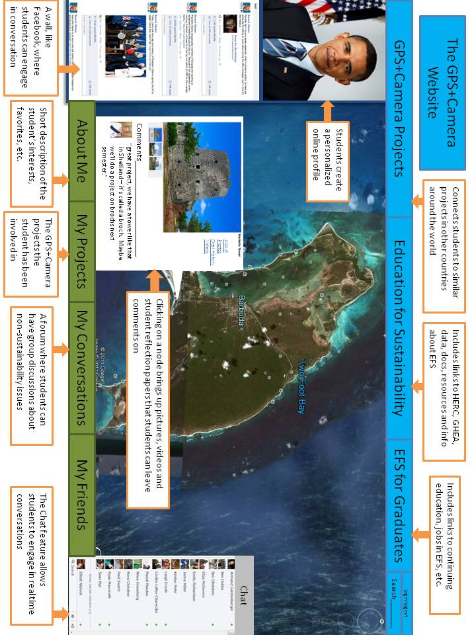

Critical thinkers ask, how can I use reliable evidence to evaluate the ideas I encounter? What is reliable evidence?
Systems thinkers ask, how do human and natural systems at different levels of scale interact to create the world we see over time?
Futures thinkers ask, how do our action today impact the future in 5, 10, 50 or 100 years?
Global Citizens ask, how do our actions impact global systems? Where do we see global systems at work in our lives? What responsibilities do we have to other communities?

