What is a GPS+Camera Project?
The GPS+Camera Project
The GPS+Camera project combines two complimentary features; 1) short environmental sustainability units in every high school subject staggered throughout the year with a strong emphasis on experiential learning, interdisciplinary connections and community engagement, and 2) a website shared by schools across the Atlantic that combines features of GoogleEarth and social networking sites like Facebook allowing students to publish their fieldwork and engage in sustainability dialogue with students abroad.
Key Features of the GPS+Camera Fieldwork Modules:
- Environmental Sustainability Units Designed Specifically for Barbuda
  - Active and experiential learning
  - Sustainability literacy
  - Spatial literacy
  - Connect with global trends in local context
- Eight Lessons per Unit and One Unit per Subject
  - Avoids overburdening any one teacher
  - Interdisciplinary sustainability perspectives
- One Project per Subject Staggered Throughout the Year
  - Year-round engagement with sustainability issues
  - Mainstreaming of environmental consciousness across school curriculum
Key Features of the GPS+Camera Website:
- Preserving Knowledge at Home
  - Youth-community dialogue around local issues of sustainability
  - Preservation of Traditional Ecological Knowledge
  - Real valuable historical, ethnographic, and ecological research
- Engaging in Sustainability Dialogue Abroad
  - Publishing original student research to an international audience
  - Systematic opportunities to regularly engage in sustainability dialogue with youth researchers worldwide
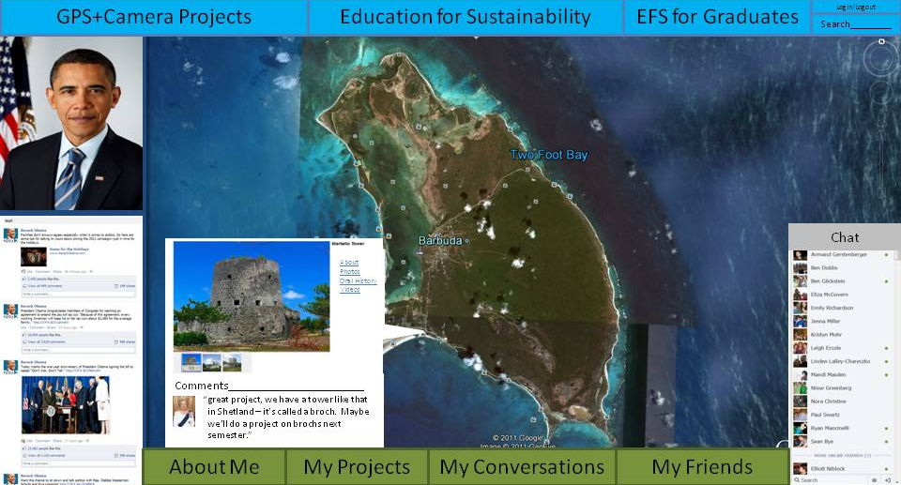
Figure 1: the GPS+Camera Website allows students to publish their spatially referenced research online and engage in international sustainability dialogue.

