Maine Sea Grant & Coastal Shell Middens
Part of the IHOPE threats to heritage and the distributed observing network of the past team response to global change impacts and the Society for American Archaeology Climate Change Strategies and the Archaeological Record committee.

Contact: Prof. Alice Kelley
Climate Change Institute
University of Maine, Orono ME 04469-5790 akelley@maine.edu , http://climatechange.umaine.edu/

Worldwide, coastal archaeological sites are being lost and/or damaged as sea-level rise and associated storm events impact the coast. In Maine, over 2,000 aboriginal shell middens, recording over 5,000 years of coastal occupation, dot the coast. Composed largely of clam and oyster shells, these deposits also contain bone, ceramic and lithic artifacts. Additionally, they contain an extensive faunal and floral record, including now extinct species, and represent a lengthy paleoenvironmental record. All of these sites are disappearing at varying rates, some catastrophically. Only 2-3 of Maine coast shell middens are professionally excavated each year, meaning that thousands of years of cultural and environmental history slips into the ocean, unrecorded each year.

Researchers from the University of Maine’s School of Earth and Climate Sciences, Department of Anthropology and Climate Change Institute and the Maine Historic Preservation Commission are supported by Maine Sea Grant in a two year effort to: 1) Use ground-penetrating radar (GPR) to develop a rapid, noninvasive technique to assess shell midden size and internal stratigraphy as a tool in archaeological site prioritization for data rescue and preservation. 2) Bring local stakeholders together with experts in coastal cultural heritage preservation to begin formulation of a culturally and environmentally sensitive approach to shell midden site monitoring, preservation, and rescue.

Site selection is designed to investigate a variety of shell midden settings in a range of geological situations, and is guided by recommendations by the Maine Historic Preservation Commission. Work at selected sites will include documentation of any previous archaeological or geophysical investigations, creating a record of historic coastline change from maps and aerial photographs, and collection of gridded GPR profiles. Study results will guide future excavation planning and document the rate of loss of these important cultural and environmental records.

Researchers:
Alice R. Kelley, School of Earth and Climate Sciences, Climate Change Institute, and Department of Anthropology, University of Maine, Orono Maine USA
Joseph T. Kelley, School of Earth and Climate Sciences and Climate Change Institute, University of Maine, Orono Maine USA
Daniel F. Belknap, School of Earth and Climate Sciences and Climate Change Institute, University of Maine, Orono Maine USA
Brian Robinson, Department of Anthropology and Climate Change Institute, University of Maine, Orono Maine USA
Arthur Spiess, Maine Historic Preservation Commission, Augusta, Maine USA
Jacqueline Miller, School of Earth and Climate Sciences, University of Maine, Orono Maine USA

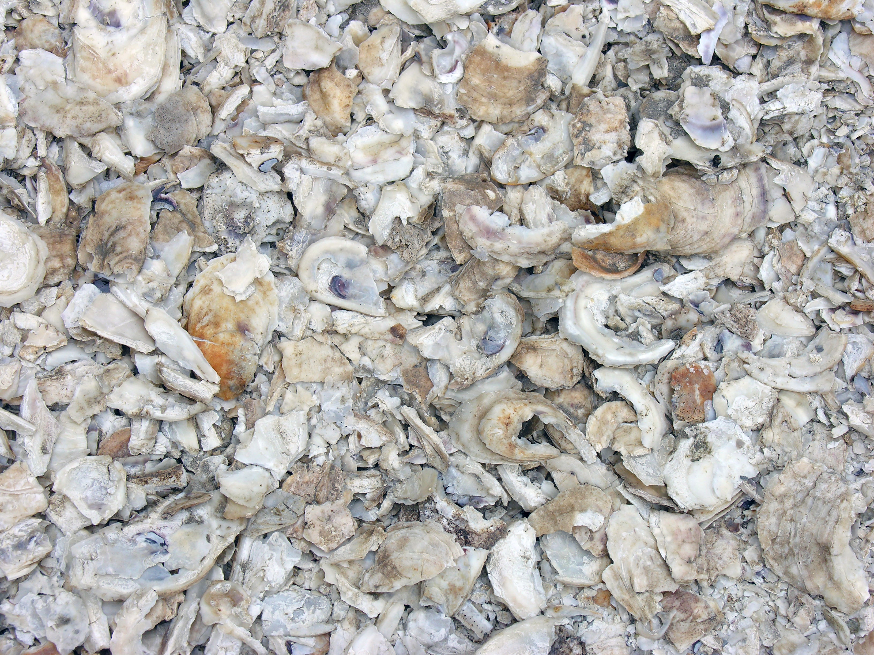
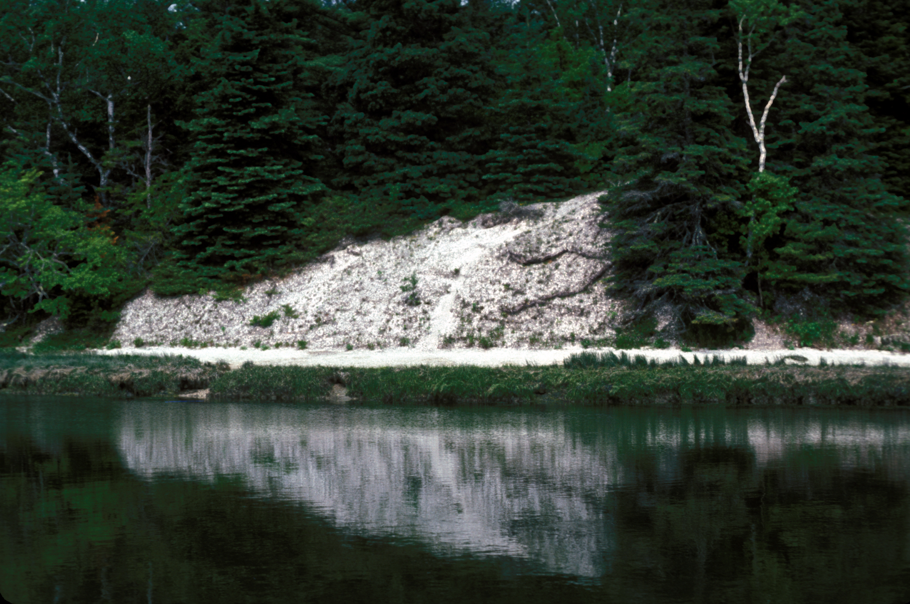
Glidden Shell Midden in Damariscotta, Maine, the largest shell midden north of Florida. The other image is a close up of the oyster shells that compose the midden. Both images by Joseph Kelley.

